Mini-Project Report: Library Management System
Object-Oriented Programming in Java — Lab 11
Tadiwanashe Mundingi (H250549X)

1. Objective
Build a console Library Management System that combines the main OOP ideas from Labs 1–10: classes and encapsulation, inheritance, abstraction, polymorphism, interfaces, custom exceptions, collections, streams, and CSV file persistence.

2. Design overview
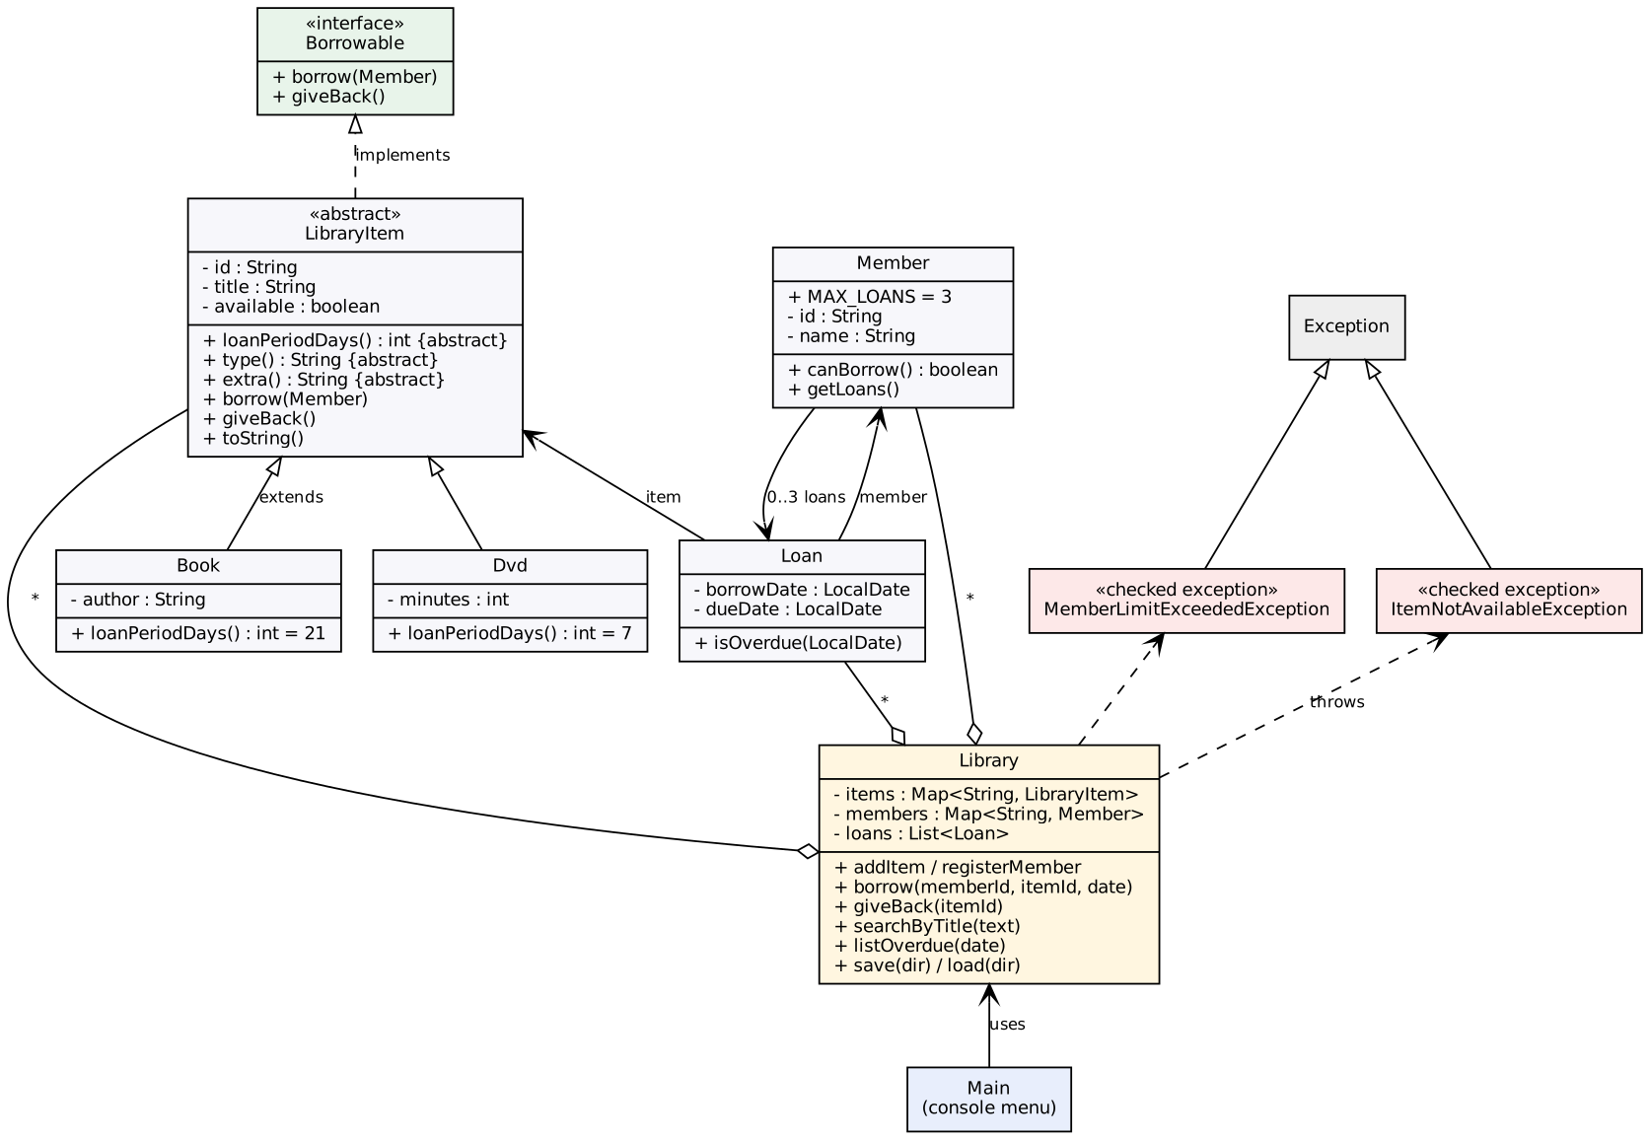
Class diagram
Class / interface | Responsibility | OOP idea shown
LibraryItem (abstract) | Holds id, title and availability; declares loanPeriodDays(), type(), extra() | Abstraction, encapsulation (private fields, validation)
Book, Dvd | Concrete items; Book = 21-day loan, DVD = 7-day loan | Inheritance, polymorphism
Borrowable (interface) | borrow(Member) and giveBack() | Programming to an interface
Member | Id, name and current loans; limit of 3 (MAX_LOANS); getLoans() returns an unmodifiable view | Encapsulation
Loan | Links an item to a member with borrow and due dates; isOverdue(date) | Composition
ItemNotAvailableException, MemberLimitExceededException | Checked, business-rule errors | Custom exceptions
Library | Owns Map<String, LibraryItem>, Map<String, Member> and the active loans; borrow, return, search, overdue, save, load | Single responsibility, collections, streams, file I/O
Csv | Reads and writes CSV lines, quoting fields that contain commas | No duplication
Main | Console menu only; no business logic | Separation of concerns

3. How each requirement is met
- Book, Member, Loan — private fields, constructors that validate (blank text, non-positive duration, null dates throw IllegalArgumentException), and toString().
- Abstract LibraryItem — Book and Dvd each override loanPeriodDays().
- Borrowable — implemented once in LibraryItem.
- Custom exceptions — Library.borrow throws MemberLimitExceededException when a member already has 3 loans and ItemNotAvailableException when the item is out. Unknown ids throw IllegalArgumentException.
- Maps keyed by id — HashMap for items and members. Duplicate ids are rejected.
- CSV persistence — save() writes items.csv, members.csv, loans.csv on exit. load() reads them at start. A missing file means a first run, and a malformed line is skipped with a warning instead of crashing. Availability is rebuilt from loans.csv, so the two files cannot disagree.
- Menu — add item, register member, borrow, return, list overdue, search by title, list all, save and exit.

4. Polymorphism in action
Library.borrow calls item.borrow(member) and new Loan(item, member, date), which calls item.loanPeriodDays(). The library never checks whether the item is a Book or a DVD. A Book borrowed on 1 Jan is due 22 Jan, and a DVD is due 8 Jan. Adding a new item type (say Magazine) needs only a new subclass, which is the open/closed principle.

5. Collections and streams
searchByTitle filters (case-insensitive contains), sorts with Comparator.comparing(LibraryItem::getTitle) and returns .toList(). listOverdue(today) filters loans with isOverdue and sorts by due date. Both take the date or text as a parameter, which makes them easy to test.

6. Testing
LibraryTests is dependency-free (run java LibraryTests) and has 30 checks, all passing:
- loan periods (polymorphism)
- validation of every constructor
- successful borrow and the due date
- unavailable item, 4th-loan limit, and unknown member or item
- return and the slot being freed
- overdue boundary (not overdue on the due date, overdue the day after)
- search (case, order, no match)
- a save/load round trip that preserves counts, availability, a comma in a title, DVD type and due dates
Manual test: sample_run_1.txt and sample_run_2.txt show two separate program runs. The loan made in run 1 is still there in run 2 and can be returned.

7. Design decisions and limitations
- Dates are passed in (LocalDate today) rather than read inside Library, so overdue logic is testable without waiting for real time.
- Checked exceptions are used for expected business failures so callers must handle them.
- No fines, renewals or reservations, and Library is single-user and not thread-safe. These are natural extensions.
- Design patterns from Lab 11 that fit well here: a Factory for creating items from CSV rows (currently an if in load), an Observer for overdue notifications, and a Strategy for per-member-type loan limits.

8. Conclusion
The system meets all seven requirements. Behaviour that varies (loan period) lives in subclasses, rules live in Library, and display lives in Main, so each class has one clear job.

